Screen print of database schema created according to physical data model in DBMS, e.g. picture of ER diagram in SQL Server

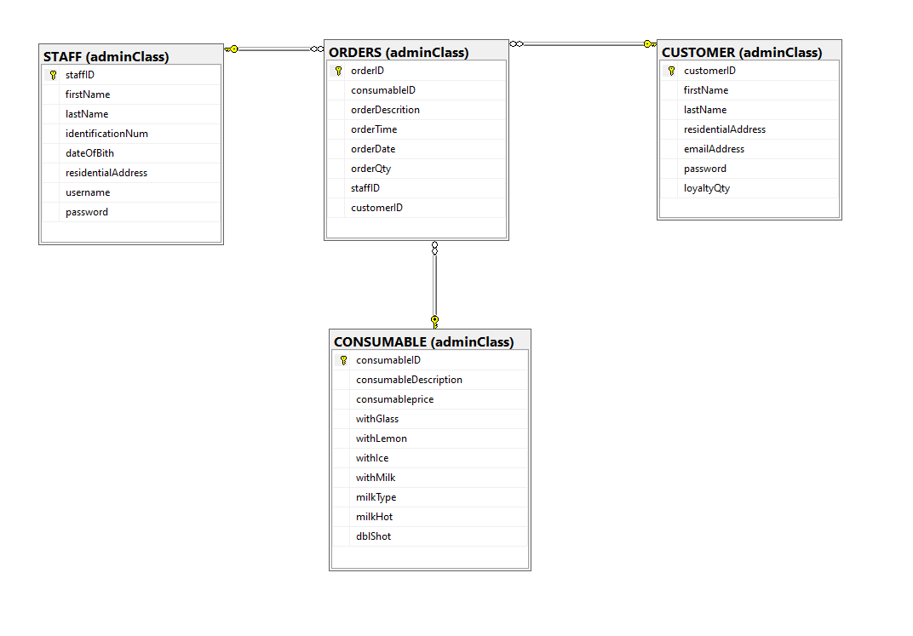

# DATABASE:

CREATE DATABASE GrindGo

use GrindGo

GO

CREATE SCHEMA adminClass

GO

CREATE TABLE adminClass.STAFF

(

staffID int identity (1,1) primary key,

firstName varchar(10),

lastName varchar(15),

identificationNum char(13),

dateOfBith date,

residentialAddress varchar(40),

username varchar(10),

password varchar(15)

)

CREATE TABLE adminClass.CUSTOMER

(

customerID int identity (1,1) primary key,

firstName varchar(10),

lastName varchar(15),

residentialAddress varchar(40),

emailAddress varchar(15),

password varchar(15),

loyaltyQty int

)

CREATE TABLE adminClass.CONSUMABLE

(

consumableID int identity (1,1) primary key,

consumableDescription varchar(40),

consumableprice smallmoney,

withGlass bit,

withLemon bit,

withIce bit,

withMilk bit,

milkType varchar(10),

milkHot bit,

dblShot bit

)

CREATE TABLE adminClass.ORDERS

(

orderID int identity (1,1) primary key,

consumableID int,

orderDescrition varchar(50),

orderTime time,

orderDate date,

orderQty char(3),

staffID int,

customerID int,

CONSTRAINT fk_adminClass_CUSTOMER_ORDERS foreign key(customerID) REFERENCES adminClass.CUSTOMER (customerID),

CONSTRAINT fk_adminClass_STAFF_ORDERS foreign key(staffID) REFERENCES adminClass.STAFF(staffID),

CONSTRAINT fk_adminClass_CONSUMABLE_ORDERS foreign key(consumableID) REFERENCES adminClass.CONSUMABLE (consumableID),

)

### INSERT:

### Consumable:

USE [GrindGo]

GO

INSERT INTO [adminClass].[CONSUMABLE]

([consumableDescription]

,[consumableprice]

,[withGlass]

,[withLemon]

,[withIce]

,[withMilk]

,[milkType]

,[milkHot]

,[dblShot])

VALUES

(<consumableDescription, varchar(40),>

,<consumableprice, smallmoney,>

,<withGlass, bit,>

,<withLemon, bit,>

,<withIce, bit,>

,<withMilk, bit,>

,<milkType, varchar(10),>

,<milkHot, bit,>

,<dblShot, bit,>)

GO

### Customer:

USE [GrindGo]

GO

INSERT INTO [adminClass].[CUSTOMER]

([firstName]

,[lastName]

,[residentialAddress]

,[emailAddress]

,[password]

,[loyaltyQty])

VALUES

(<firstName, varchar(10),>

,<lastName, varchar(15),>

,<residentialAddress, varchar(40),>

,<emailAddress, varchar(15),>

,<password, varchar(15),>

,<loyaltyQty, int,>)

GO

### Order:

USE [GrindGo]

GO

INSERT INTO [adminClass].[ORDERS]

([consumableID]

,[orderDescrition]

,[orderTime]

,[orderDate]

,[orderQty]

,[staffID]

,[customerID])

VALUES

(<consumableID, int,>

,<orderDescrition, varchar(50),>

,<orderTime, time(7),>

,<orderDate, date,>

,<orderQty, char(3),>

,<staffID, int,>

,<customerID, int,>)

GO

### Staff:

USE [GrindGo]

GO

INSERT INTO [adminClass].[STAFF]

([firstName]

,[lastName]

,[identificationNum]

,[dateOfBith]

,[residentialAddress]

,[username]

,[password])

VALUES

(<firstName, varchar(10),>

,<lastName, varchar(15),>

,<identificationNum, char(13),>

,<dateOfBith, date,>

,<residentialAddress, varchar(40),>

,<username, varchar(10),>

,<password, varchar(15),>)

GO

### UPDATE:

### Consumable:

USE [GrindGo]

GO

UPDATE [adminClass].[CONSUMABLE]

SET [consumableDescription] = <consumableDescription, varchar(40),>

,[consumableprice] = <consumableprice, smallmoney,>

,[withGlass] = <withGlass, bit,>

,[withLemon] = <withLemon, bit,>

,[withIce] = <withIce, bit,>

,[withMilk] = <withMilk, bit,>

,[milkType] = <milkType, varchar(10),>

,[milkHot] = <milkHot, bit,>

,[dblShot] = <dblShot, bit,>

WHERE <Search Conditions,,>

GO

### Customer:

USE [GrindGo]

GO

UPDATE [adminClass].[CUSTOMER]

SET [firstName] = <firstName, varchar(10),>

,[lastName] = <lastName, varchar(15),>

,[residentialAddress] = <residentialAddress, varchar(40),>

,[emailAddress] = <emailAddress, varchar(15),>

,[password] = <password, varchar(15),>

,[loyaltyQty] = <loyaltyQty, int,>

WHERE <Search Conditions,,>

GO

### Order:

USE [GrindGo]

GO

UPDATE [adminClass].[ORDERS]

SET [consumableID] = <consumableID, int,>

,[orderDescrition] = <orderDescrition, varchar(50),>

,[orderTime] = <orderTime, time(7),>

,[orderDate] = <orderDate, date,>

,[orderQty] = <orderQty, char(3),>

,[staffID] = <staffID, int,>

,[customerID] = <customerID, int,>

WHERE <Search Conditions,,>

GO

### Staff:

USE [GrindGo]

GO

UPDATE [adminClass].[STAFF]

SET [firstName] = <firstName, varchar(10),>

,[lastName] = <lastName, varchar(15),>

,[identificationNum] = <identificationNum, char(13),>

,[dateOfBith] = <dateOfBith, date,>

,[residentialAddress] = <residentialAddress, varchar(40),>

,[username] = <username, varchar(10),>

,[password] = <password, varchar(15),>

WHERE <Search Conditions,,>

GO

### DELETE:

### Consumable:

USE [GrindGo]

GO

DELETE FROM [adminClass].[CONSUMABLE]

WHERE <Search Conditions,,>

GO

### Customer:

USE [GrindGo]

GO

DELETE FROM [adminClass].[CUSTOMER]

WHERE <Search Conditions,,>

GO

### Order:

USE [GrindGo]

GO

DELETE FROM [adminClass].[ORDERS]

WHERE <Search Conditions,,>

GO

### Staff:

USE [GrindGo]

GO

DELETE FROM [adminClass].[STAFF]

WHERE <Search Conditions,,>

GO

# SELECT:

### ORDERS:

USE [GrindGo]

GO

SELECT [orderID]

,[consumableID]

,[orderDescrition]

,[orderTime]

,[orderDate]

,[orderQty]

,[staffID]

,[customerID]

FROM [adminClass].[ORDERS]

GO

### CUSTOMERS:

USE [GrindGo]

GO

SELECT [customerID]

,[firstName]

,[lastName]

,[residentialAddress]

,[emailAddress]

,[password]

,[loyaltyQty]

FROM [adminClass].[CUSTOMER]

GO

### STAFF:

USE [GrindGo]

GO

SELECT [staffID]

,[firstName]

,[lastName]

,[identificationNum]

,[dateOfBith]

,[residentialAddress]

,[username]

,[password]

FROM [adminClass].[STAFF]

GO

### CONSUMABLE:

USE [GrindGo]

GO

SELECT [consumableID]

,[consumableDescription]

,[consumableprice]

,[withGlass]

,[withLemon]

,[withIce]

,[withMilk]

,[milkType]

,[milkHot]

,[dblShot]

FROM [adminClass].[CONSUMABLE]

GO